Parameter Sweeps and Multiple Testing
Why testing multiple parameters is fine — and how to interpret the results correctly
A companion guide to Understanding Win Rate Edge Testing
Craig's Edge Testing Framework · 2026

Introduction
When you test an entry signal, you rarely test just one parameter setting. If you are using a Donchian Channel, you might try periods of 5, 10, 15, 20, 25, and 30 to understand where the edge lives — or whether it exists at all. This is called a parameter sweep, and it is good research practice.
But testing multiple things introduces a statistical concern: the more tests you run, the higher the chance that one of them will clear a confidence threshold by pure luck. This guide explains what that risk actually is, how to avoid over-interpreting it, and — most importantly — how to read a sweep result so it tells you the truth about your strategy rather than just the best-looking number.
The key message:
Testing multiple parameters is not the problem. Reporting only the best-looking one as if you had tested nothing else — that is the problem. This guide shows the difference.

1 What Is a Parameter Sweep?
A parameter sweep is simply running the same concept across a range of settings to understand how the edge behaves. For a Donchian breakout strategy you might ask: does the entry edge appear at period 10? Period 20? Everywhere between 15 and 25? Nowhere at all?
You are not fishing for any indicator that works. You are examining one specific concept — breakout momentum — and asking how sensitive it is to the lookback window. That is a fundamentally different activity.
The sweep answers three questions simultaneously:
- Existence: Does the concept show edge at all on this market?
- Location: At what parameter range does the edge appear? Narrow spike or broad plateau?
- Robustness: Is the edge consistent across the range, or only at one specific value?
These three answers together are far more informative than any single backtest result.

2 The Multiple Testing Problem — Explained Simply
Here is the core statistical issue. When you claim a result is significant at 95% confidence, you are saying there is a 5% chance it is a false positive — a result that looks real but is actually just random variation.
That 5% is calculated assuming you ran exactly one test. If you ran six tests, the 5% applies to each test independently. The probability that at least one of them produces a false positive grows with every test you add.
False positive risk by number of tests (at 95% confidence per test)
Tests Run | False Positive Risk | Plain English
1 test | 5.0% | As advertised
2 tests | 9.8% | Nearly 1 in 10
3 tests | 14.3% | About 1 in 7
6 tests | 26.5% | More than 1 in 4
10 tests | 40.1% | About 2 in 5
20 tests | 64.2% | More likely than not

This does not mean you should only ever test one thing. It means you should understand that the confidence figure on your best result is overstated if you found it through a search. The chart below makes this visual.
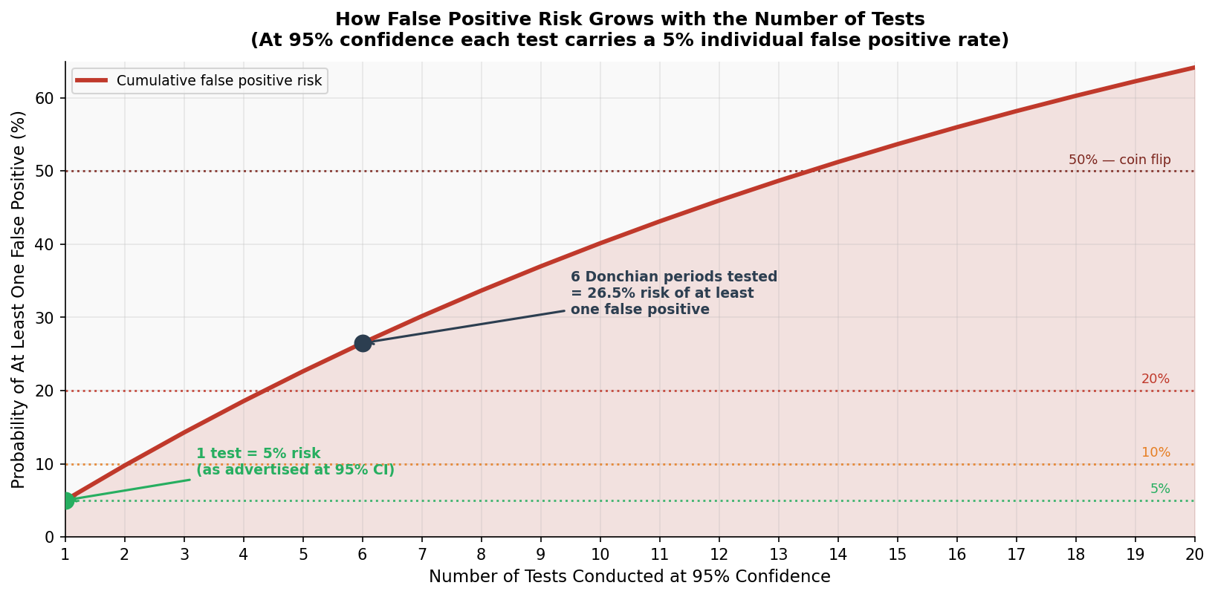
Figure 1 — False positive risk accumulates quickly. Testing six Donchian periods at 95% confidence gives a combined 26.5% risk of at least one false positive — more than five times the advertised 5%.

3 Reading the Sweep — Shape Matters More Than the Peak
If you run a sweep and the result is that exactly one parameter produces a significant Z-score while everything around it fails, you should be suspicious. But if several parameters across a coherent range all show edge, that is a genuinely informative result.
The shape of the sweep result — the pattern across all parameters — is the real signal. The height of the peak at any single parameter is just one data point.
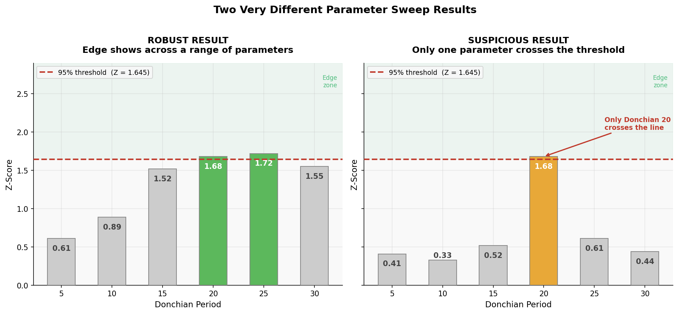
Figure 2 — The same Z-score of 1.68 at Donchian 20 means something very different depending on what the surrounding parameters show. Left: a broad plateau — the concept is robust. Right: an isolated spike — likely a lucky hit or curve-fit.

What the sweep shape tells you:
Broad plateau (multiple periods show edge): The concept itself has edge on this market. The exact parameter is less critical — the mechanism is working across a range. This is the result you want.
Narrow peak (2-3 adjacent periods): Possible real edge, but you are more dependent on getting the parameter right. Cross-market validation becomes even more important.
Single isolated spike: Treat with scepticism. One parameter clearing the threshold while everything around it fails is exactly what a false positive looks like. Require higher Z-score or independent market confirmation before trusting it.
Gradually rising or falling trend: Informative about market character. If Z increases with longer periods on US30, it tells you that market needs a wider channel to filter the noise.

4 Concept-Level Edge vs Parameter-Specific Edge
This distinction is the most important thing to take from a parameter sweep.
 | Concept-Level Edge | Parameter-Specific Edge
What it is | The entry mechanism works across a range of parameter settings | Only one (or very few) specific parameter values show edge
Sweep pattern | Broad plateau — multiple periods clear the threshold | Isolated spike — one period works, neighbours do not
Reliability | High. The edge is structural, not dependent on a lucky number | Low. Likely a curve-fit to historical data
Live trading | Parameter drifts slightly and strategy still works | Small change in parameter and edge disappears
Your response | Pick any parameter in the plateau. Focus on cross-market validation | Require much stronger Z-score or independent confirmation before trusting

The Donchian US100 result (Z = 3.93 at period 10) suggests concept-level edge. The US30 result (Z = 1.68 at period 20 only) needs cross-market confirmation before you can determine which category it falls into.

5 Adjacent Parameters Are Not Independent Tests
Here is an important nuance that softens the multiple testing concern for parameter sweeps specifically.
When you test Donchian 19 and Donchian 20, you are not running two truly independent experiments. The signals they produce overlap heavily — most of the same breakouts are captured by both periods. The tests are correlated, not independent.
This matters because the false positive risk table from Section 2 assumes completely independent tests. In reality, testing Donchian 5, 10, 15, 20, 25, 30 is not the same as testing six unrelated strategies. The actual false positive risk is lower than the table suggests — though still higher than a single test.
A rough guide to test independence:
Donchian 19 vs Donchian 20: ~95% correlated — almost the same test. Very little additional false positive risk.
Donchian 10 vs Donchian 20: ~60-70% correlated — meaningfully different signals but still related.
Donchian 10 vs RSI reversal: Near zero correlation — genuinely independent tests. Full false positive risk applies.
Donchian 10 on US100 vs US30: Different markets — independent results. Each genuinely adds evidence.

The practical takeaway: a sweep of adjacent Donchian periods is less statistically problematic than it first appears. But testing Donchian, RSI, and Bollinger Bands is a much higher multiple testing burden, because those are genuinely independent mechanisms — each one is a separate bet on a different market explanation.

6 The Cross-Market Grid — The Most Powerful View
The cleanest way to resolve all the ambiguity from a parameter sweep is to look at results across multiple markets simultaneously. This is the cross-market × parameter grid.
For each combination of market and Donchian period, you record the Z-score from the vs-random test. The grid instantly shows you where the concept works, at what scale, and whether it is structural or market-specific.
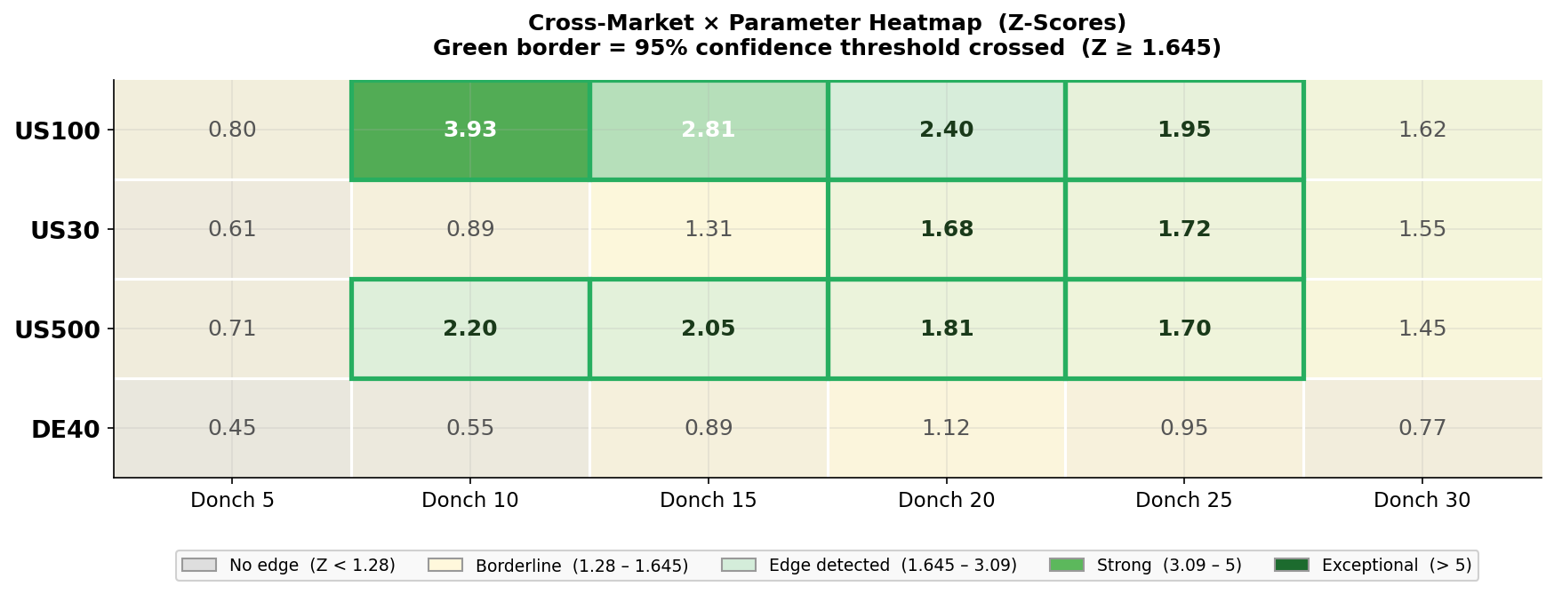
Figure 3 — The cross-market × parameter heatmap. Each cell shows the Z-score for that market / period combination. Green borders indicate 95%+ confidence. The pattern immediately reveals where the edge is structural (US100, US500 at Donch 10–20) vs market-specific (DE40 shows nothing) and parameter-specific (US30 needs a longer lookback).

How to read the heatmap:
- Strong column: A column that is green across multiple markets means that parameter shows edge broadly. Strong evidence.
- Strong row: A row that is green across multiple periods means that market responds to Donchian breakouts across a range of lookbacks. The concept is robust on that market.
- Isolated green cell: A single green cell surrounded by grey is a warning sign — regardless of the Z-score inside it.
- All grey market: A market with no green cells tells you the concept has no edge there. Do not force it.
The heatmap also makes the multiple testing problem largely irrelevant. If Donchian 20 shows Z = 1.68 on US30 AND Z = 1.81 on US500 independently, the probability that both are false positives simultaneously is approximately 5% × 5% = 0.25%. Two independent markets confirming the same result is far stronger evidence than any single-market Z-score.
Why two independent markets beat a higher Z-score on one market:
Single market, Z = 2.33 → 99% confidence → 1 in 100 chance of false positive
Two markets, each Z = 1.68 → 95% × 95% → 0.25% chance both are false positives
Independent market confirmation is a more reliable signal than a single very high Z-score, because it proves the edge is not specific to one instrument's history.

7 The Donchian US30 Case Study
Let us apply all of this to the actual results discussed.
Market | Period | Z-Score | Conf. | Interpretation
US100 | 10 | 3.93 | >99.99% | Exceptional. Single test, first parameter tried. Concept confirmed.
US30 | 10 | <1.28 | <90% | No edge. Same period, different market character.
US30 | 20 | 1.68 | ~95% | Crosses threshold but from a second test. Needs cross-market check.

The US30 Donchian 20 result tells a coherent story: the Donchian breakout concept may work on US30 but needs a longer lookback window to filter the noise that Donchian 10 was reacting to. US30 (30 large-cap stocks) is more event-driven and less cleanly trending than US100, so a wider channel makes intuitive sense.
The next logical step is to run Donchian 20 specifically on US500. Not a sweep — just Donchian 20, locked in, tested once.
Resolving the US30 result — step by step:
Step 1: Lock in Donchian 20 as the parameter to validate. Do not sweep US500.
Step 2: Run the vs-random test on US500 with Donchian 20. Record the Z-score.
Step 3: If Z >= 1.645 on US500: two independent markets confirm the result. Multiple testing concern is resolved. Treat as genuine edge.
Step 4: If Z < 1.28 on US500: the US30 result is probably parameter-specific. Do not proceed to live trading on the basis of US30 alone.
Step 5: If US500 is borderline: try one more independent market (DE40 or US30 with a completely different date range) before deciding.

8 The Complete Decision Framework
Here is the full process for running a parameter sweep and knowing what to do with the results at each stage.
Step 1 — Run the sweep
Test your concept across a sensible range of parameter values. For Donchian, test periods from 5 to 40 in steps of 5. Record the Z-score for each. Do not stop early because one value looks good.
Step 2 — Read the shape, not just the peak
Is there a broad plateau where multiple parameters show edge? A narrow peak? An isolated spike? This shape tells you whether you have concept-level edge or a lucky parameter. Write down your honest assessment of the shape.
Step 3 — Identify your best single parameter
From the sweep, select the parameter that is most central to the region of highest Z-scores. If 15, 20, and 25 all show edge, pick 20. Do not cherry-pick the absolute highest Z.
Step 4 — Lock it and cross-market test
Fix the parameter you selected. Test it on one independent market. Do not sweep parameters on the new market — test your chosen parameter only.
Step 5 — Interpret the combined evidence
Broad sweep plateau + cross-market confirmation: strong concept-level edge.
Narrow sweep + cross-market confirmation: real but parameter-sensitive edge. Proceed carefully.
Isolated spike + no cross-market: do not proceed. The result is likely a false positive.
Step 6 — Document what you tested
Record every parameter you tested, not just the winner. This protects you from lying to yourself about the true false positive risk and gives you honest context when you review results later.

9 Common Mistakes
"I found Z = 1.68 after testing six parameters — that is 95% confidence."
No — it is closer to 73% effective confidence after accounting for six tests. Cross-market validation restores the confidence level more cleanly than any statistical correction formula.
"The parameter with the highest Z-score is the best parameter."
Not necessarily. The highest Z-score from a sweep may be a noisy outlier. A parameter in the centre of a broad plateau is more reliable than the absolute peak of an isolated spike.
"I should set Z >= 2.33 (99%) to correct for multiple testing."
A higher threshold helps, but is not the right tool here. Adjacent Donchian periods are not independent tests, so the standard Bonferroni correction overcorrects. Cross-market validation is a cleaner and more practically useful answer to the same problem.
"No edge in the sweep means the concept is wrong."
Not necessarily. It may mean the concept needs a completely different exit structure on that market. Try the MFEMAEEdge test (bar-count exits) before concluding the entry concept has no merit.
"A broad plateau on one market is enough to trade."
A robust sweep on one market proves the concept is not parameter-sensitive on that market. It does not prove the concept is not specific to that market's history. Always do at least one independent cross-market test before deploying.

Quick Reference Summary
Parameter Sweeps — in 60 seconds
✓ Testing multiple parameters of the same concept is fine — it is necessary research.
✓ The shape of the sweep matters more than any individual Z-score.
✓ Broad plateau = concept-level edge. Isolated spike = suspicious, needs more evidence.
✓ Adjacent parameters are correlated — the false positive risk is lower than for independent tests.
✓ Testing completely different indicators (RSI, Bollinger, MACD) carries the full multiple testing burden.
✓ Cross-market validation with a fixed parameter is the cleanest way to confirm a sweep result.
✓ Two independent markets confirming the same parameter beats a higher Z-score on one market.
✓ Document every parameter you tested — not just the one that worked.

Disclaimer: This guide is provided strictly for informational and educational purposes. It does not constitute financial, investment, or trading advice. All examples use hypothetical data to illustrate statistical concepts. Past performance and statistical significance in backtests do not guarantee future results. Trading involves substantial risk. Conduct your own independent research and consult a licensed financial advisor before making any investment or trading decisions.

