User Guide: How the Test Was Performed for the Win Rate Edge Result Panel
This guide explains how to compare a theory-based entry against a large sample of random entries using Algo Wizard, Builder, Retester, and the Win Rate Edge panel. The goal is to determine whether a specific entry method shows a measurable edge over random trade timing.

1. Prepare the Random Entry Block
I used a custom block called RAND (Random Entry). I uploaded it to the SQX site and also attached it to the Discord message.
The block works on bar close and decides whether to open a trade based on a defined probability. Ideally, run it on the 1-minute timeframe because this produces far more random entry opportunities. On H1, for example, you only have 24 potential entry points per day. Adjust the probability value to control the number of random trades in the backtest. For example, a value of 2 means there is a 2% chance that the builder will place a trade at each bar close. This allows the builder to generate random trades for comparison against the theory or logic being tested. I will return to the builder configuration shortly.

2. Build the Theory Test in Algo Wizard
Build the theory in Algo Wizard. In this example, the test uses Donchian Channels to assess whether a 10-period buy stop on NAS100/NQ/NASDAQ has an edge. I created a template in which the signal is always true and the entry is set to Stop at Highest High (10). I combined this with a 300 stop loss and a 300 take profit, creating a 1:1 risk-reward ratio. Running the backtest produced 5,264 trades, which is a strong sample size.
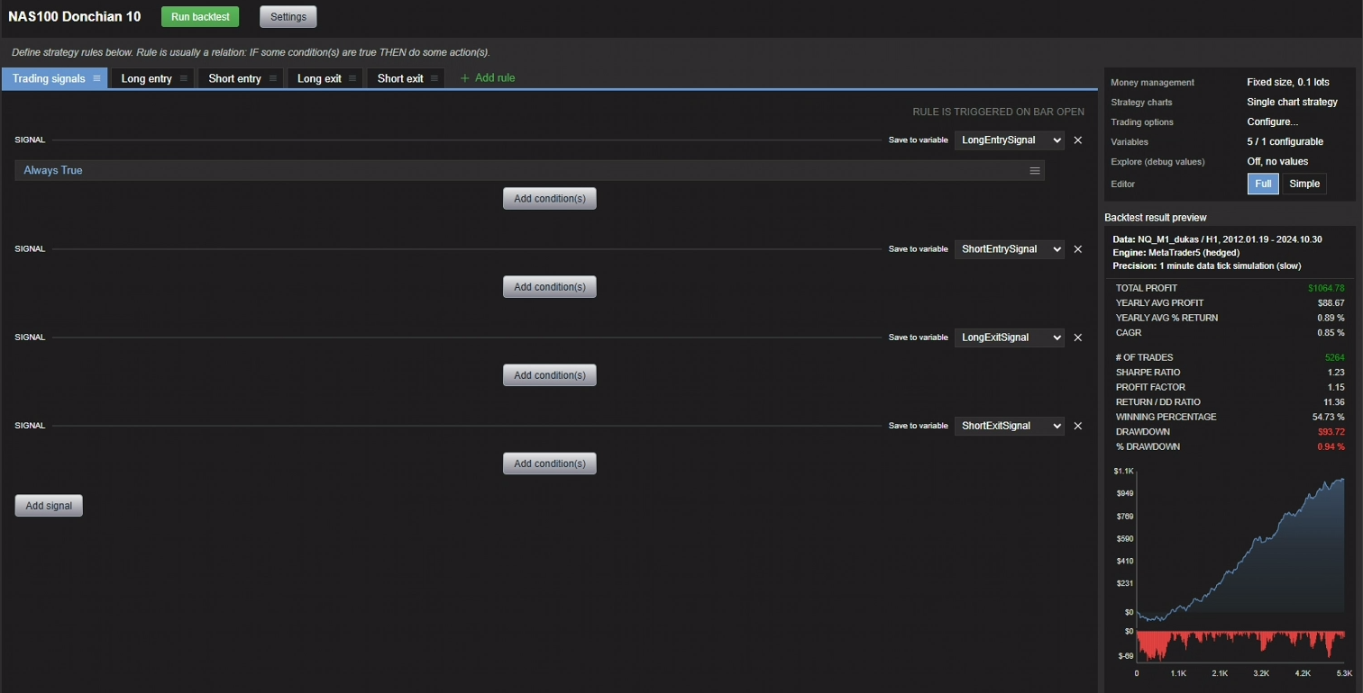
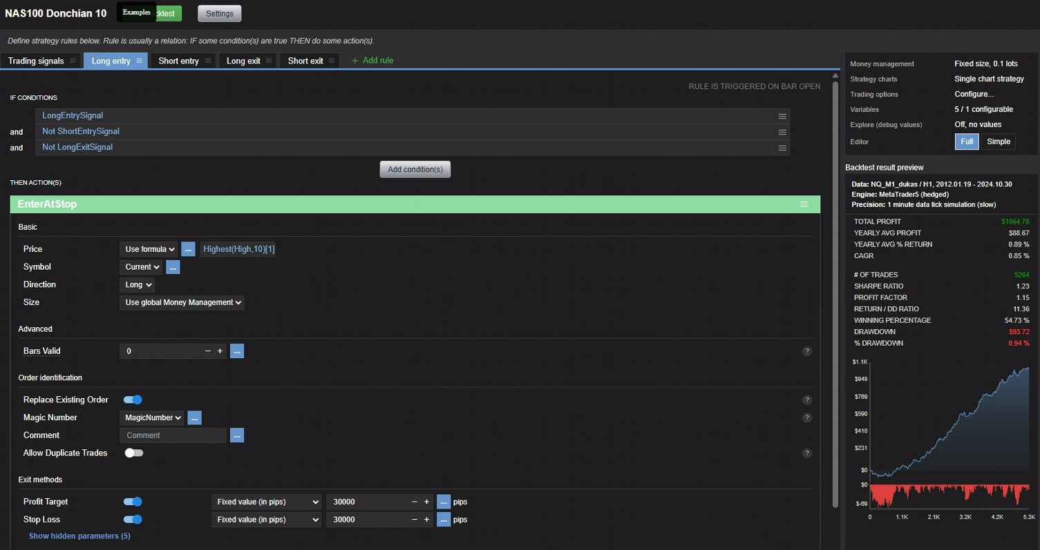

3. Match the Random-Trade Sample to the Theory Test
Next, create a large sample of random trades for comparison. This is where the RAND block is used. Configure the builder so it matches the edge-test backtest as closely as possible. In my test, I set the builder to Simple Strategy, Long only, Random Signal, and Conditions = 1. I also required both a stop loss and a profit target, and matched them exactly to the values used in the Algo Wizard test.
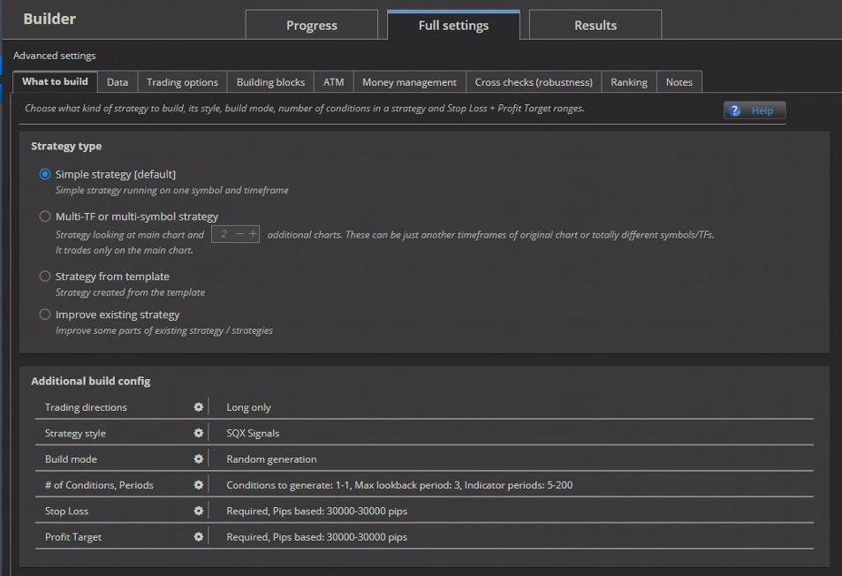
In the data settings, again match the Algo Wizard test exactly, but set the timeframe to M1 to create more randomness. Also use the same date range.
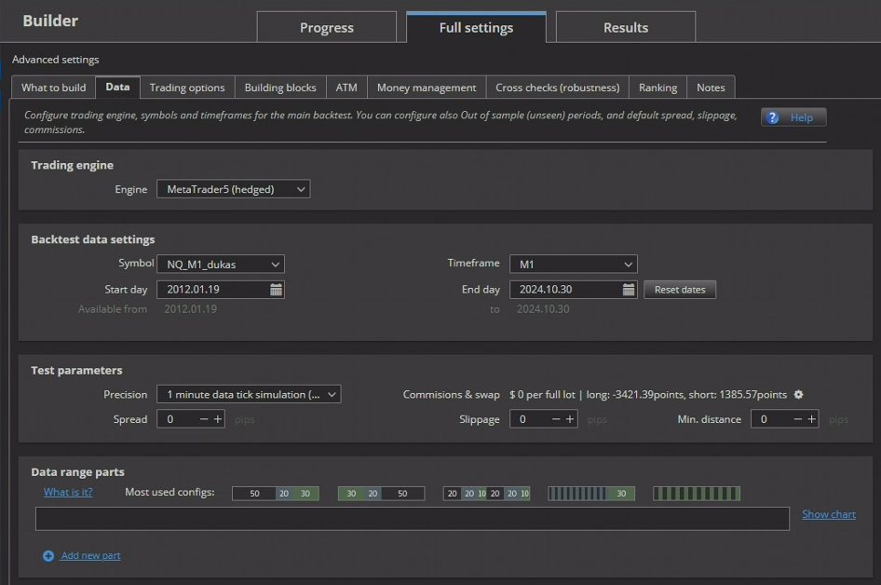
Leave Trading Options blank so they remain the same as in Algo Wizard.
In Building Blocks, select only the RAND block and Market Order. Double-check that both Stop Loss and Profit Target are set to Required.
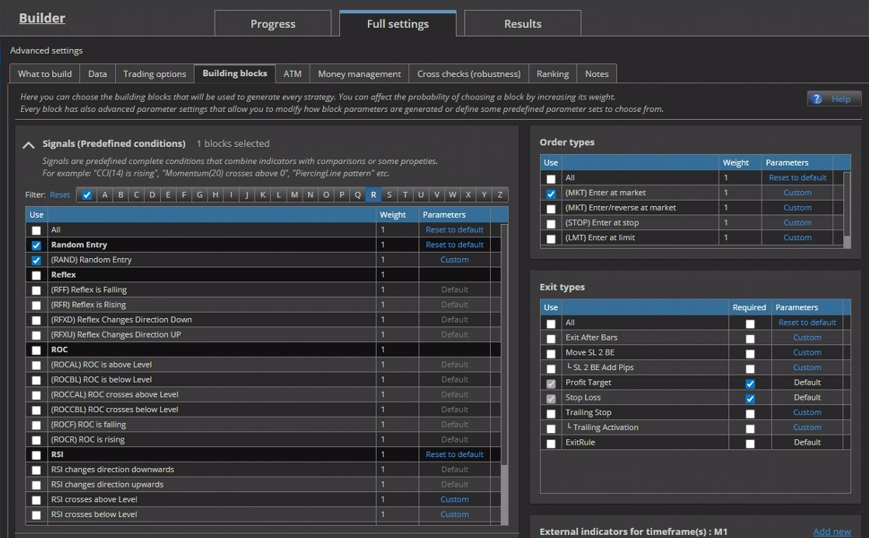
To set the probability on the RAND block, select Custom, then open Parameter Values. In the screenshot below, the value is set to 0.05%.
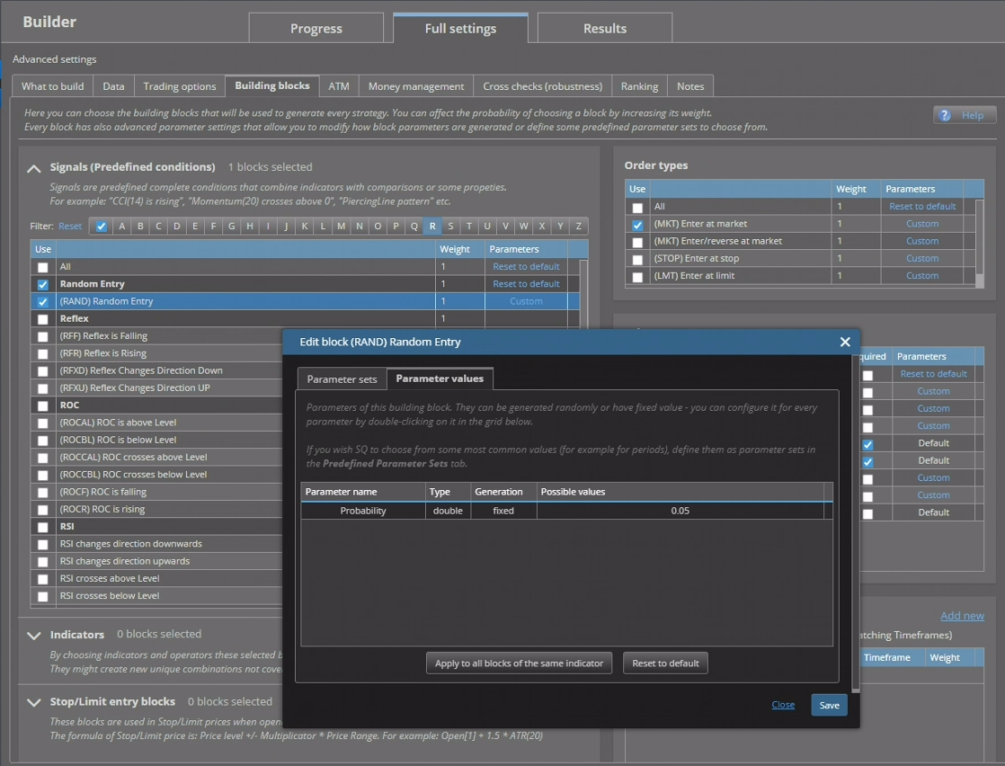
You can also choose to randomise the probability value if you wish, but this can make the number of trades per backtest vary significantly. I prefer controlling the trade count directly. Either way, the trades will still be random.

4. Run the Random Backtests
Set money management to Fixed Lot or Fixed Dollar. Do not use percentage-based balance sizing, as this will distort the results.
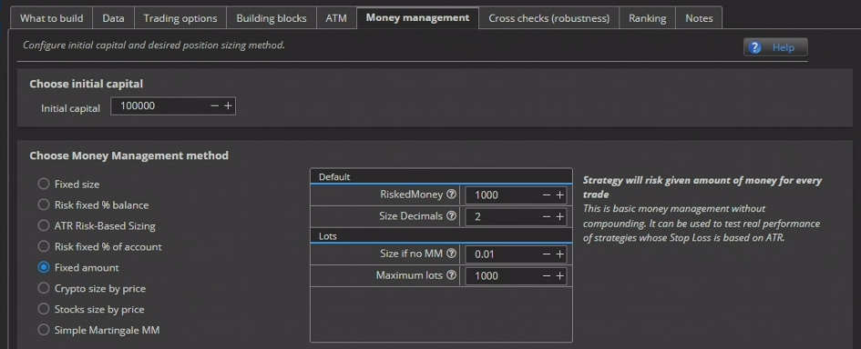
Do not run any cross-checks or rankings. Once everything is ready, run the backtest. It should take only a short time to generate 1,000 strategies. The number of backtests required depends on how many trades you need for the versus-random test. My theory backtest produced 5,260 trades, and because random NQ trades are easy to generate, I eventually built a combined sample of approximately 72,000 random trades.

5. Load the Tests into Retester and Review the Edge
Next, bring the edge or theory backtest from Algo Wizard into Retester using File – Save to Retester. Then import a selection of backtests from the builder into Retester as well.
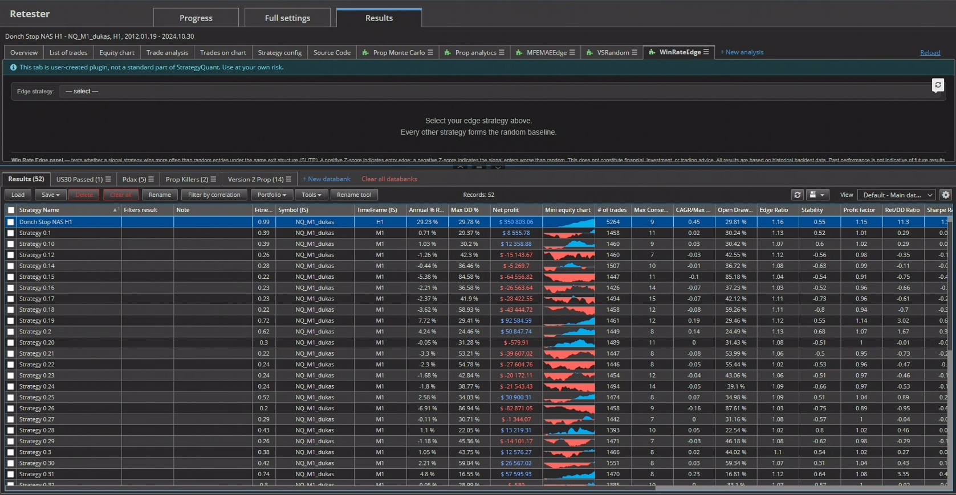
As shown above, the P&L values for the random backtests can vary widely. That is expected. At this stage, the focus is not on overall performance, but on win rate. Specifically, the question is whether a Donchian 10 entry has any predictive power or advantage compared with entering trades at completely random times.
Combine the tests into a portfolio and load it. In the Win Rate Edge panel, you will see a loading message while the trades are processed. When loading is complete, use the dropdown list to select your edge backtest.
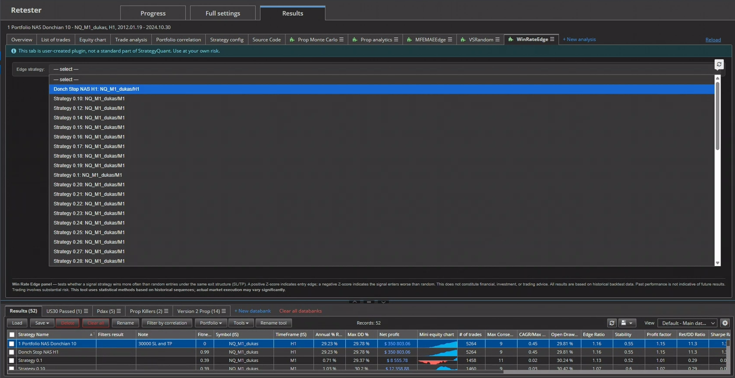
You should now see a result screen similar to the example below.
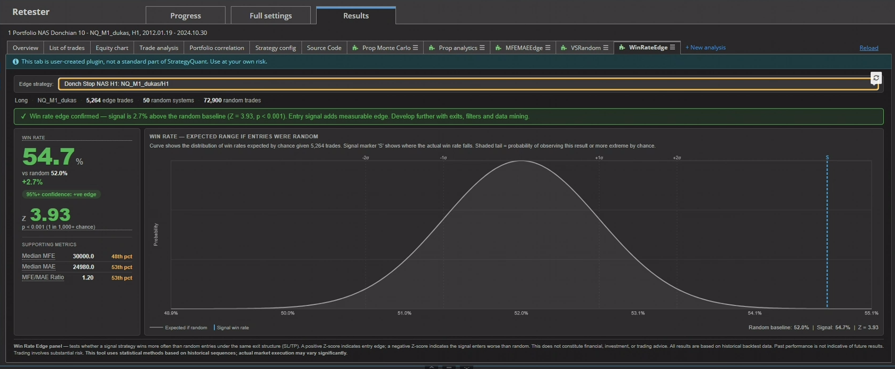
In this example, the results show that the Donchian Channel 10 entry does have an edge. The edge may only be 2.7%, but as explained in my Win Rate Edge Testing Guide, this is the type of result we are looking for.
I also plan to release a further test for MAE/MFE edge analysis to complement this process. The purpose of that test is to determine whether an entry, signal, or theory captures more favourable price movement than random entries. If true edge exists, the MAE/MFE ratio should also compare more favourably against random entries. This can help confirm the win-rate edge and highlight possible areas for take-profit levels, trailing logic, and related trade-management decisions. For example, this Donchian entry may show strong MFE versus random entries over 2, 5, and 10 bars, but then weaken over 15, 20, and 30 bars. That would indicate how long trades can potentially be held before the edge fades towards random expectation.

